1. Create a Flask application with an /api route

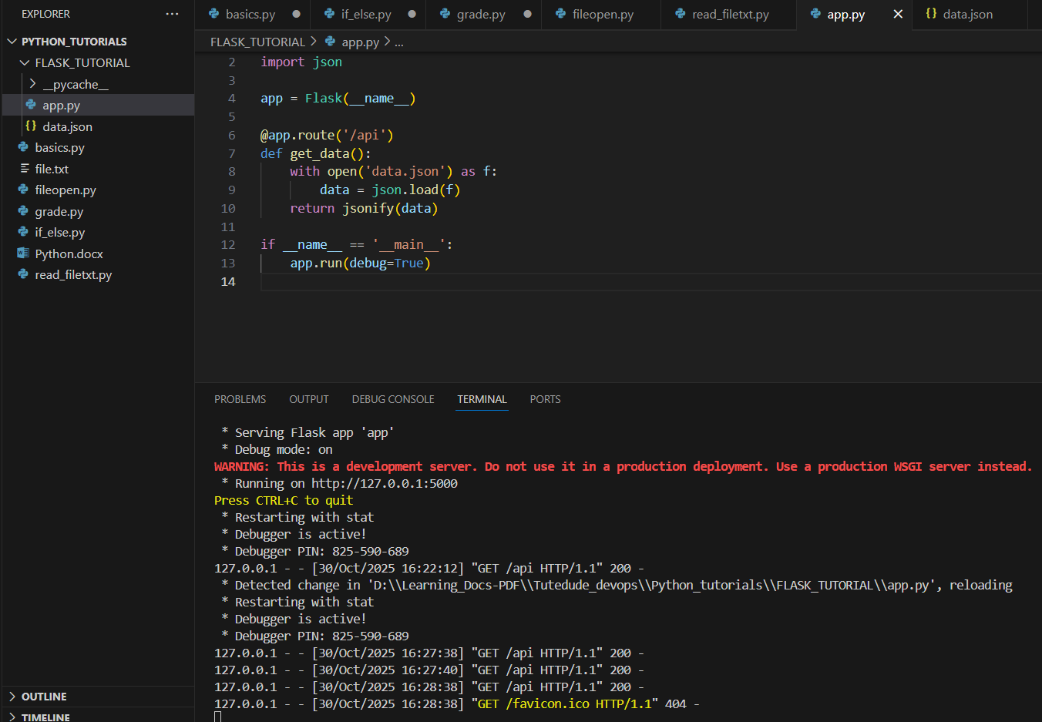

Data.json:

[

  {"id": 1, "name": "bob", "role": "Developer"},

  {"id": 2, "name": "mohit", "role": "Designer"},

  {"id": 3, "name": "tam", "role": "Manager"}

]

Browser Output:

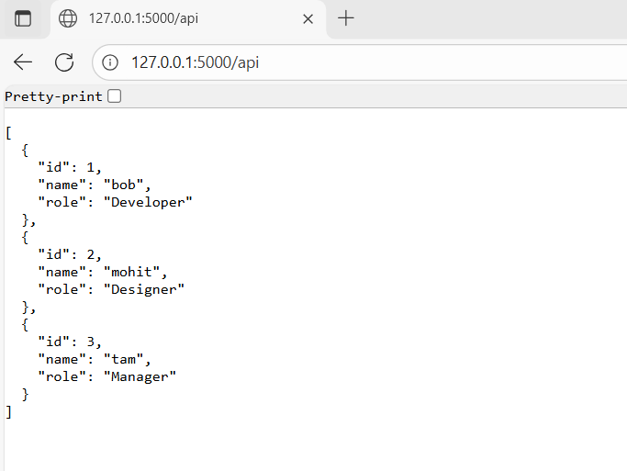

1. **Create a form on the frontend:**

App.py

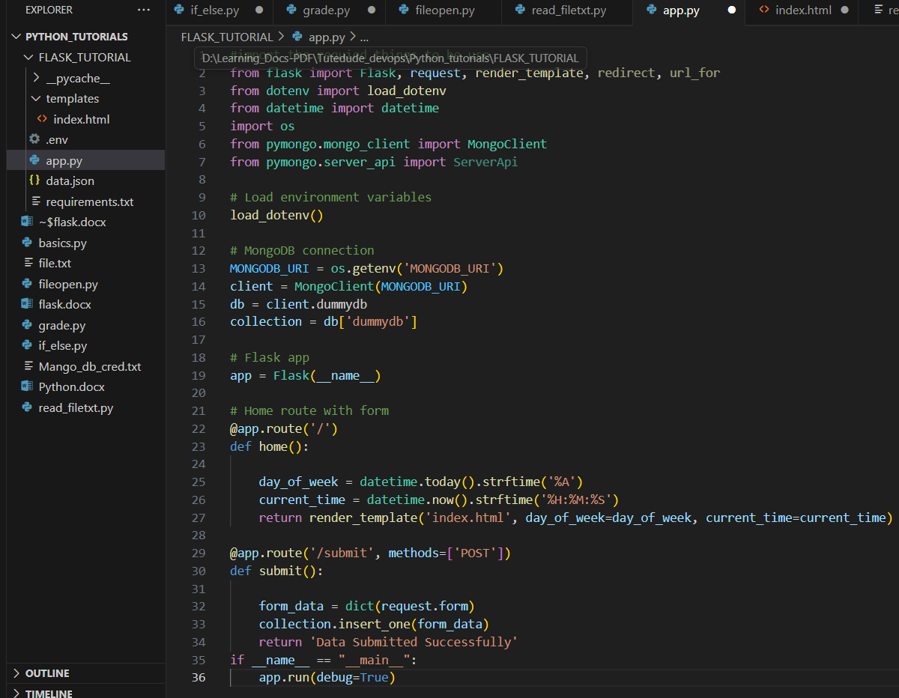

.env



Index.html

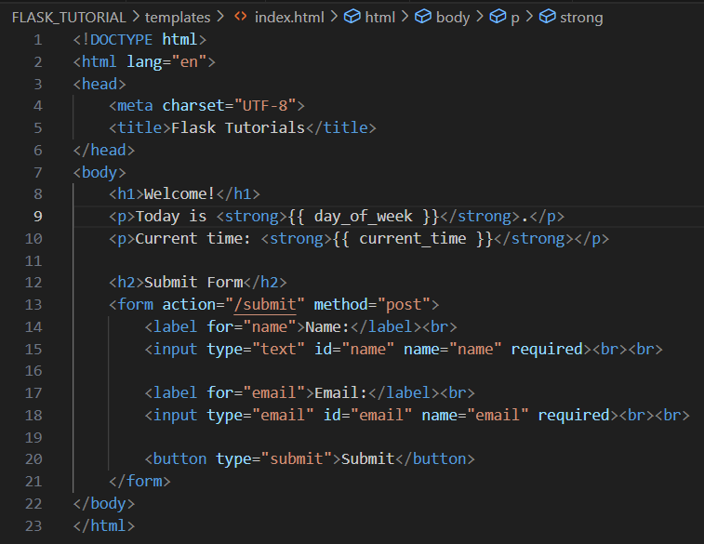

Form:

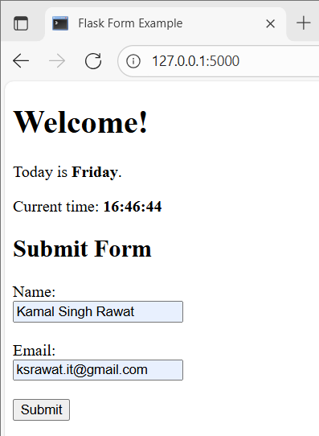

Data sumbmission successfully message

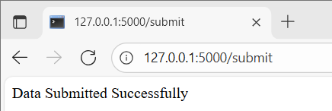

Data stored in database:

